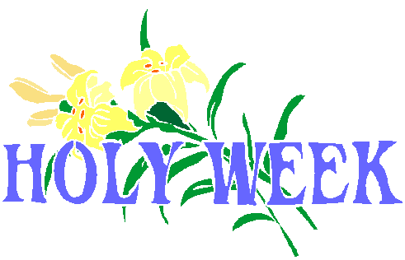

**Sunday**, April 14th, Palm Sunday (Matthew 21:1-11,

Mark 11:1-11, Luke 19:28-44, John 12-19)

**Monday,** April 15th, (Matthew 21:12-22 Mark 11:15-19, Luke 11:19-45-48, John 2:13-17)

**Tuesday**, April 16th, Senior Bible Study (10:30am)

**Wednesday**, April 17th, Prayer and Bible Study (6:30pm)

**Thursday**, April 18th, Maundy Thursday, Remembering the

last super and Jesus’s last Commandment given

(Matthew 26:17- 75, Mark 14:12-72, Luke 22:7-62, John 17:1-38)

**Friday**, April 19th, Good Friday Christ’s crucifixion and death

(Matthew 27:1-62, Mark15:1-47,

Luke 22:63-23:56, John 18:28-19:37)

**Saturday**, April 20th, Holy Saturday

(Matthew 27:62-66, Luke 23:56, John 19:40)

**Sunday**, April 21st, Resurrection Sunday (HE IS RISEN!!!!)

(Matthew 28:1-13, Mark 16:1-14, Luke 24:1-49, John 20:1-23)

